20160913
# Here is how to fix troubles with stucked job in iDRAC.

# One way is to remove all jobs.
[support@centos00 20160815-1714]$ SSHPASS="$(pass common/windows-current)" sshpass -e ssh -t -oStrictHostKeyChecking=no tcsbank.ru\\s.belogrud@hg2h8d2.mgmt.tcsbank.ru racadm getsysinfo | tee -a /tmp/$(date +%Y%m%d-%H%M).getsysinfo.hg2h8d2.log

[support@centos00 20160815-1714]$ SSHPASS="$(pass common/windows-current)" sshpass -e ssh -t -oStrictHostKeyChecking=no tcsbank.ru\\s.belogrud@hg2h8d2.mgmt.tcsbank.ru racadm jobqueue delete -i JID_CLEARALL_FORCE | tee -a /tmp/$(date +%Y%m%d-%H%M).getsysinfo.hg2h8d2.log
Created Job Identifier:
RAC1032: JID_CLEARALL_FORCE job(s) was cancelled by the user.
Connection to hg2h8d2.mgmt.tcsbank.ru closed.
[support@centos00 20160815-1714]$

[support@centos00 20160815-1714]$ SSHPASS="$(pass common/windows-current)" sshpass -e ssh -t -oStrictHostKeyChecking=no tcsbank.ru\\s.belogrud@hg2h8d2.mgmt.tcsbank.ru racadm jobqueue view | tee -a /tmp/$(date +%Y%m%d-%H%M).getsysinfo.hg2h8d2.log
-------------------------JOB QUEUE------------------------
Connection to hg2h8d2.mgmt.tcsbank.ru closed.
[support@centos00 20160815-1714]$

# The second way is try to do racreset. It could be done after the first method too.
[support@centos00 20160815-1714]$ ssh -t -oStrictHostKeyChecking=no root@10.219.9.140 racadm racreset | tee -a /tmp/$(date +%Y%m%d-%H%M).getsysinfo.40zj8d2.log
root@10.219.9.140's password:
RAC reset operation initiated successfully. It may take a few
minutes for the RAC to come online again.
Connection to 10.219.9.140 closed.
[support@centos00 20160815-1714]$

#
# Same as above. Just little improved.
#
[support@centos00 20161011-1831]$ SSHPASS="$(pass common/windows-current)" sshpass -e ssh -t -oStrictHostKeyChecking=no tcsbank.ru\\s.belogrud@6zvn8d2.mgmt.tcsbank.ru racadm jobqueue delete -i JID_CLEARALL_FORCE | tee -a ./$(date +%Y%m%d-%H%M).racadm.jobqueue.delete.6zvn8d2.log
Created Job Identifier:
RAC1032: JID_CLEARALL_FORCE job(s) was cancelled by the user.
Connection to 6zvn8d2.mgmt.tcsbank.ru closed.
[support@centos00 20161011-1831]$

[support@centos00 20161011-1831]$ SSHPASS="$(pass common/windows-current)" sshpass -e ssh -t -oStrictHostKeyChecking=no tcsbank.ru\\s.belogrud@6zvn8d2.mgmt.tcsbank.ru racadm jobqueue view | tee - a ./$(date +%Y%m%d-%H%M).racadm.jobqueue.view.6zvn8d2.log
-------------------------JOB QUEUE------------------------
Connection to 6zvn8d2.mgmt.tcsbank.ru closed.
[support@centos00 20161011-1831]$

[support@centos00 20161011-1831]$ SSHPASS="$(pass common/windows-current)" sshpass -e ssh -t -oStrictHostKeyChecking=no tcsbank.ru\\s.belogrud@6zvn8d2.mgmt.tcsbank.ru racadm racreset | tee -a ./ $(date +%Y%m%d-%H%M).racadm.racreset.6zvn8d2.log
RAC reset operation initiated successfully. It may take a few
minutes for the RAC to come online again.
Connection to 6zvn8d2.mgmt.tcsbank.ru closed.
[support@centos00 20161011-1831]$

Здравствуйте. Ни как не удаётся применить шаблон конфигурации из Dell OME к данному серверу. Шаблон применён уже к более, чем 100 серверов, но с этим сервером возник сбой. Red Hat - Enterprise

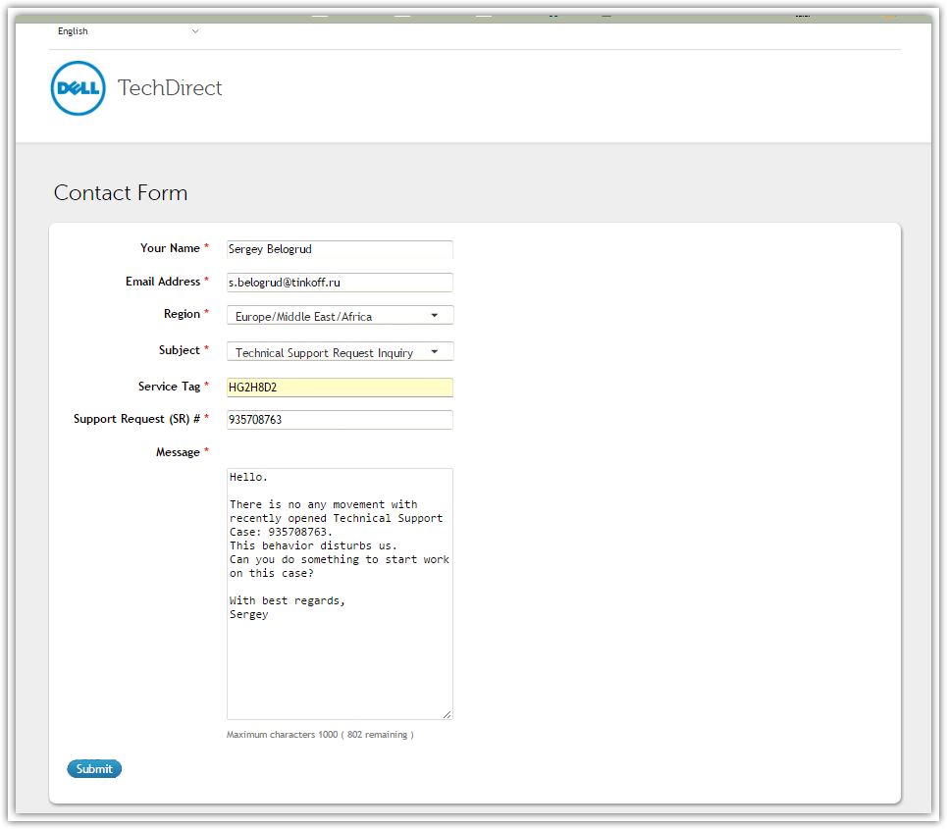

From: Belogrud Sergey Vladimirovich
Sent: Tuesday, September 13, 2016 4:52 PM
To: 'Piotr.Kretkiewicz@dell.com'
Subject: RE: Dell Support Case: 935708763 [R730]

Добрый день Пётр.

Спасибо.
Помогло.
Кейс можно закрывать.

Сергей Белогруд
Старший системный администратор
Тел.: +7 495 648-10-00, доб. 2173

From: Piotr.Kretkiewicz@dell.com [mailto:Piotr.Kretkiewicz@dell.com]
Sent: Tuesday, September 13, 2016 10:47 AM
To: Belogrud Sergey Vladimirovich
Subject: RE: Dell Support Case: 935708763 [R730]

Добрый день Сергей!

Я получил ответ:

I think, the job queue must be deleted. This will not be done, after the idrac reset.

Can be used this racadm command: http://blog.igics.com/2014/08/how-to-clear-all-jobs-on-dell-lifecycle.html

Надеюсь что это поможет

С уважением,

Пётр Креткевич
Enterprise Technical Support Analyst
Dell | Global Support Services
piotr_kretkiewicz@dell.com

Dell Halle GmbH in Vertretung der Dell GmbH, Raffineriestraße 28, 06112 Halle (Saale), Germany
Geschäftsführer: Doris Albiez, Sanjay Tyagi
Vorsitzender des Aufsichtsrates: Jürgen Renz
Eingetragen beim Amtsgericht Stendal unter HRB 215298, USt.-ID: DE242553389
WEEE-Reg.Nr. der Dell GmbH: DE 49515708

Если у вас возникли положительные или отрицательные впечатления от работы по этому кейсу (заявке), напишите небольшое письмо моему менеджеру, который отвечает за качество работы поддержки по серверам:

Олег Удовенко Oleg_Udovenko@dell.com на русском языке
Sven Jung Sven_Jung@dell.com на английском языке

Номера горячей линии поддержки:
ProSupport
Россия: +7 499 500 8393 / 8 10 800 209 71044
Украина: 0800 502 0340 / 0800 502 034
Эстония: 0800-2226
Латвия: 800 028 87
Литва: 880 030 097
Казахстан: +7 800 333 4225 / +7 800 333 4218
Азербайджан: 0887773355

Поддержка на русском языке работает с понедельника по пятницу с 8 до 18 по московскому и киевскому времени. В остальное время звонки автоматически переводятся на английскую линию поддержки.

From: Belogrud Sergey Vladimirovich [mailto:s.belogrud@tinkoff.ru]
Sent: Montag, 12. September 2016 16:35
To: Kretkiewicz, Piotr <Piotr_Kretkiewicz@Dell.com>
Subject: RE: Dell Support Case: 935708763 [R730]

Здравствуйте Пётр.

Жду результатов.

Сергей Белогруд
Старший системный администратор
Тел.: +7 495 648-10-00, доб. 2173

From: Piotr.Kretkiewicz@dell.com [mailto:Piotr.Kretkiewicz@dell.com]
Sent: Monday, September 12, 2016 5:34 PM
To: Belogrud Sergey Vladimirovich
Subject: Dell Support Case: 935708763 [R730]

Добрый день Сергей,

Извините за задержку с ответом. Я сегодня вернулся с отпуска и буду заниматься Вашим вопросом.
Мне нужно будет проконсультировать Ваш кейс с нашим OME экспертом. Сейчас жду ответа от него.

С уважением,

Пётр Креткевич
Enterprise Technical Support Analyst
Dell | Global Support Services
piotr_kretkiewicz@dell.com

Dell Halle GmbH in Vertretung der Dell GmbH, Raffineriestraße 28, 06112 Halle (Saale), Germany
Geschäftsführer: Doris Albiez, Sanjay Tyagi
Vorsitzender des Aufsichtsrates: Jürgen Renz
Eingetragen beim Amtsgericht Stendal unter HRB 215298, USt.-ID: DE242553389
WEEE-Reg.Nr. der Dell GmbH: DE 49515708

Если у вас возникли положительные или отрицательные впечатления от работы по этому кейсу (заявке), напишите небольшое письмо моему менеджеру, который отвечает за качество работы поддержки по серверам:

Олег Удовенко Oleg_Udovenko@dell.com на русском языке
Sven Jung Sven_Jung@dell.com на английском языке

Номера горячей линии поддержки:
ProSupport
Россия: +7 499 500 8393 / 8 10 800 209 71044
Украина: 0800 502 0340 / 0800 502 034
Эстония: 0800-2226
Латвия: 800 028 87
Литва: 880 030 097
Казахстан: +7 800 333 4225 / +7 800 333 4218
Азербайджан: 0887773355

Поддержка на русском языке работает с понедельника по пятницу с 8 до 18 по московскому и киевскому времени. В остальное время звонки автоматически переводятся на английскую линию поддержки.

From: Belogrud Sergey Vladimirovich
Sent: Tuesday, September 06, 2016 7:39 PM
To: 'EMEA_ProSupport_SRV_OOH_ACG@Dell.com'
Subject: RE: Auto Generated Unassigned SRs

I have collected TSR report.
Could you add it to this case, please?

Sergey Belogrud Vladimirovich
Senior Linux Systems Administrator
Tel.: +7 495 648-10-00, ext. 2173

From: Belogrud Sergey Vladimirovich
Sent: Tuesday, September 06, 2016 7:31 PM
To: 'EMEA_ProSupport_SRV_OOH_ACG@Dell.com'
Subject: RE: Auto Generated Unassigned SRs

Hello Jacob.

I confirm these information.
And will write some more details.

• Preferred mode of contact for this issue (Phone/Email): Email
• Preferred Language: Russian
• Preferred time of contact: since 11:00 AM till 8:00 PM GMT+3 (Russia Moscow time zone)

I’d like to add few related notes for this case.

Here are messages, I’ve received during apply our iDRAC configuration template.

Starting deploy server configuration task 'Deploy Template - Deploy Template Task - 09/06/2016 18:17:33'.
Using Compute Pool: common config (ID=4)
Using Template: PowerEdge R730xd - iDRAC - common config (ID=882)
Using Identity Set: None (manual identity assignment)
Boot-to-Network-ISO after deploy: No
Shutdown mode: Graceful-then-Forced (2)

Doing task-specific processing...
This task will use manually-assigned virtual identities.
Done with task-specific processing

* Deploying the template...

Network share IP for this task: 10.216.43.159

Retrieved the file share settings.
Deploy server config returned an error:
> Return Code = 2
> Message = Server has pending or commited system configuration.
> Message ID = LC068
File clean up failed : The system cannot find the file specified

> Template deployment failed.
A deployment job could not be created on the iDRAC.
- Template validation will be skipped

I tried to do rackreset, but it didn’t help to fix this issue.

[support@centos00 20160815-1714]$ ssh tcsbank.ru\\s.belogrud@hg2h8d2.mgmt.tcsbank.ru
tcsbank.ru\s.belogrud@hg2h8d2.mgmt.tcsbank.ru's password:
/admin1-> racadm
racadm>>racreset
racadm racreset
RAC reset operation initiated successfully. It may take a few
minutes for the RAC to come online again.
racadm>>quit

/admin1-> exit
CLP Session terminated
Connection to hg2h8d2.mgmt.tcsbank.ru closed.
[support@centos00 20160815-1714]

Below are some details about this server.

[root@ds-cassandra01p ~]# dmidecode -t system
# dmidecode 2.12-dmifs
# SMBIOS entry point at 0x7af0a000
SMBIOS 2.8 present.

Handle 0x0100, DMI type 1, 27 bytes
System Information
Manufacturer: Dell Inc.
Product Name: PowerEdge R730
Version: Not Specified
Serial Number: HG2H8D2
UUID: 4C4C4544-0047-3210-8048-C8C04F384432
Wake-up Type: Power Switch
SKU Number: SKU=NotProvided;ModelName=PowerEdge R730
Family: Not Specified

Handle 0x0C00, DMI type 12, 5 bytes
System Configuration Options
Option 1: NVRAM_CLR: Clear user settable NVRAM areas and set defaults
Option 2: PWRD_EN: Close to enable password

Handle 0x2000, DMI type 32, 11 bytes
System Boot Information
Status: No errors detected

[root@ds-cassandra01p ~]# cat /etc/redhat-release
Red Hat Enterprise Linux Server release 7.2 (Maipo)
[root@ds-cassandra01p ~]#

Sergey Belogrud Vladimirovich
Senior Linux Systems Administrator
Tel.: +7 495 648-10-00, ext. 2173

From: EMEA_ProSupport_SRV_OOH_ACG@Dell.com [mailto:EMEA_ProSupport_SRV_OOH_ACG@Dell.com]
Sent: Tuesday, September 06, 2016 7:13 PM
To: Belogrud Sergey Vladimirovich
Subject: FW: Auto Generated Unassigned SRs

Dear Mr. Belogrud,

We have received the below Service Request Ticket, SR# 935708763 from your side and would like to know if you would be available for
further Diagnosis and Troubleshooting?

This ticket has been generated for the Dell Service tag: HG2H8D2 for Model: R730,SANDSTORM PE.

We see these are the details provided on the alert, do you confirm if these are correct

• Name of Technical Contact: Sergey Belogrud
• Contact Number along with country code: +74956481000ext.2173 / +79150464278
• Email address: s.belogrud@tinkoff.ru
• Preferred mode of contact for this issue (Phone/Email): ?
• Preferred Language: ?
• Preferred time of contact: ?

Once we get the above information, we shall be able to work on the ticket.

Jacob Mathew
Enterprise Technical Support Senior Associate

From: ServiceWfmail [mailto:ServiceWfmail_11g@dell.com]
Sent: Tuesday, September 06, 2016 9:30 PM
Subject: Auto Generated Unassigned SRs

DC - Global - Unassigned SRs

SR Owner Group | Source | SR # | Time Open (Min) | SR Opened Date (UTC) | SR Owner | Status | Severity | Last Upd By | Last Upd Date (UTC)
ENT.ACD.PRO_SRV.TS.EMEA.RU | OLIM2 | 935708763 | 18 | 9/6/2016 3:42:44 PM | NO_OWNER | Submitted | 3-Medium | SERVICE_INTERFACE_USER | 9/6/2016 3:42:44 PM

http://blog.igics.com/2014/08/how-to-clear-all-jobs-on-dell-lifecycle.html

How to clear all jobs on DELL Lifecycle Controller via iDRAC
When you have problem with DELL Lifecycle Controller jobs you can delete all jobs by single iDRAC command. This command

racadm -r ip address -u user name -p password jobqueue delete -i JID_CLEARALL_FORCE

deletes all of the jobs plus the orphaned pending and restarts the data manager service on the iDRAC. It will take about 90-120 secs before the iDRAC is able to process another job.

Occasionally the iDRAC may need to be reset after issuing the above command due to other issues outside the job queue processing. In such case you can issue commands in the following order:
- racadm -r ip address -u user name -p password jobqueue delete -i JID_CLEARALL_FORCE
- Wait 120 secs
- racadm –r ip address –u user name –p password racreset

Posted by David Pasek at 11:29 AM
Email ThisBlogThis!Share to TwitterShare to FacebookShare to Pinterest
Labels: DELL, DELL OpenManage, iDRAC, LC, Lifecycle Controller, system management

5 comments:
Anonymous said...
Thank you! This command allowed us to get past the "ERROR: RAC961: A pending or committed system configuration change exists.
Wait until the configuration changes are applied before starting
another import operation. Use the "racadm jobqueue view" command to
check the status of the current import operation." which was showing even after all jobs were cleared from the job queue.
4:34 PM
Anonymous said...
Thank you! This command allowed us to get past the "ERROR: RAC961: A pending or committed system configuration change exists.
Wait until the configuration changes are applied before starting
another import operation. Use the "racadm jobqueue view" command to
check the status of the current import operation." which was showing even after all jobs were cleared from the job queue.
4:36 PM
Anonymous said...
Same here. Thanks!
9:19 AM
Viktor said...
Many thanks,

That really comes in handy when troubleshooting DELL servers.
11:39 AM
Anonymous said...
Thanks as well. Even with a call to dell tech support we couldn't get past the RAC961 error.
7:45 PM

[support@centos00 20161011-1831]$ SSHPASS="$(pass common/windows-current)" sshpass -e ssh -t -oStrictHostKeyChecking=no tcsbank.ru\\s.belogrud@6zvn8d2.mgmt.tcsbank.ru racadm jobqueue delete -i JID_CLEARALL_FORCE | tee -a ./$(date +%Y%m%d-%H%M).racadm.jobqueue.delete.6zvn8d2.log
Created Job Identifier:
RAC1032: JID_CLEARALL_FORCE job(s) was cancelled by the user.
Connection to 6zvn8d2.mgmt.tcsbank.ru closed.
[support@centos00 20161011-1831]$

[support@centos00 20161011-1831]$ SSHPASS="$(pass common/windows-current)" sshpass -e ssh -t -oStrictHostKeyChecking=no tcsbank.ru\\s.belogrud@6zvn8d2.mgmt.tcsbank.ru racadm jobqueue view | tee - a ./$(date +%Y%m%d-%H%M).racadm.jobqueue.view.6zvn8d2.log
-------------------------JOB QUEUE------------------------
Connection to 6zvn8d2.mgmt.tcsbank.ru closed.
[support@centos00 20161011-1831]$

[support@centos00 20161011-1831]$ SSHPASS="$(pass common/windows-current)" sshpass -e ssh -t -oStrictHostKeyChecking=no tcsbank.ru\\s.belogrud@6zvn8d2.mgmt.tcsbank.ru racadm racreset | tee -a ./ $(date +%Y%m%d-%H%M).racadm.racreset.6zvn8d2.log
RAC reset operation initiated successfully. It may take a few
minutes for the RAC to come online again.
Connection to 6zvn8d2.mgmt.tcsbank.ru closed.
[support@centos00 20161011-1831]$

#
# 20190228
#

From: Vladimir.Derzavin@dell.com <Vladimir.Derzavin@dell.com>
Sent: Thursday, February 28, 2019 11:36 AM
To: Leonov Aleksey Vladimirovich <a.leonov@tinkoff.ru>; Piotr.Kretkiewicz@dell.com; Mostapha.Belhout@dell.com
Cc: loberman@redhat.com; Terentev Aleksey <a.terentyev@tinkoff.ru>; support@redhat.com; rgirase@redhat.com; yoliynyk@redhat.com; rargade@redhat.com; Artyom.Denisyuk@dell.com; Belogrud Sergey Vladimirovich <s.belogrud@tinkoff.ru>; Aleksandrov Aleksey Valerievich <a.v.aleksandrov@tinkoff.ru>; Shcherbakov Oleg <o.shcherbakov@tinkoff.ru>; mpg@redhat.com; Marat.Rashitov@Dell.com; Audrey.Challier@dell.com; Alexander.Pavlov@dell.com; Artem.Bulkin@dell.com; Andrej.Ficner@dell.com
Subject: RE: (WoC) (SEV 1) Case #02314465 (samsung(dell) nvme lost namespace) ref:_00DA0HxWH._5002KcjZ0Q:ref

Hello Aleksey,

In my opinion it is either a Web-GUI glitch and the firmware is already installed/downgraded, or we would need to clear the Job Queue completely and reboot the iDRAC module (restart does not affect the production, only remote control module itself will be cycled).

If that will not help there is an option to clear the Job Queue manually from CLI:

Connect SSH
To clear and remove the error you must clear the job queue via Secure Shell (SSH).
To do this you must use a Secure Shell (SSH) client like putty. Enter the IP of the affected iDRAC like below:
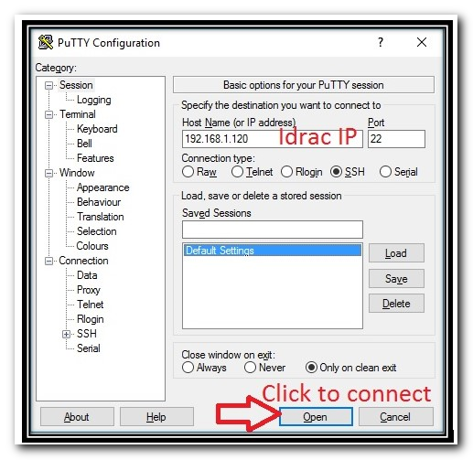
(Fig.3 PuTTY configuration window)
Please login to the secure session using root & password of the iDRAC.

Clear Job Queue Command
To clear the iDRAC Job queue use following command:

racadm jobqueue delete -i JID_CLEARALL_FORCE

This will delete all the iDRAC's job queue items. Expected output:

login as: root
root@10.213.12.13#s password:
/admin1-> racadm jobqueue delete -i JID_CLEARALL_FORCE
Create Job Identifier:
RAC1032; JID_CLEARALL_FORCE job(s) was cancelled by the user.
/admin1->

You should now be able to upload iDRAC updates using normal methods.

For detailed information about the tool and its usage, please check the RACADM Command Line Interface Reference Guide (version 2.10.10.10. or later, only in English)

Best regards,

Vladimir Derzavin
Enterprise Resolution Manager
Dell EMC | Customer Support Services
office +49 345 782 25870, internal 31 25870
Vladimir.Derzavin@Dell.com

From: Leonov Aleksey Vladimirovich <a.leonov@tinkoff.ru>
Sent: Donnerstag, 28. Februar 2019 06:48
To: Derzavin, Vladimir; Kretkiewicz, Piotr; Belhout, Mostapha
Cc: 'loberman@redhat.com'; Terentev Aleksey; 'support@redhat.com'; 'rgirase@redhat.com'; 'yoliynyk@redhat.com'; 'rargade@redhat.com'; Denisyuk, Artyom; Belogrud Sergey Vladimirovich; Aleksandrov Aleksey Valerievich; Shcherbakov Oleg; 'mpg@redhat.com'; Rashitov, Marat; Challier, Audrey; Pavlov, Alexander; Bulkin, Artem; Ficner, Andrej
Subject: RE: (WoC) (SEV 1) Case #02314465 (samsung(dell) nvme lost namespace) ref:_00DA0HxWH._5002KcjZ0Q:ref

[EXTERNAL EMAIL]
Hello

An attempt was made to roll back the firmware of nvme controllers to 36 servers. 31 rolled back successfully. 5 fails rollback for one reason. Help me to understand.
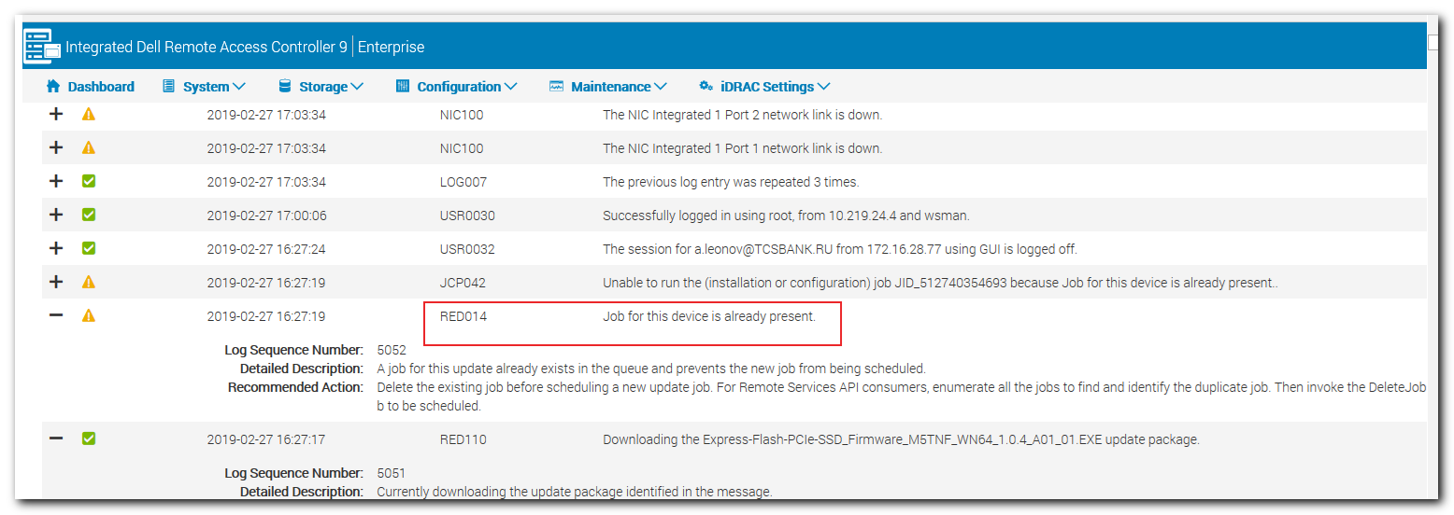

when try to rollback again, one and the same error occurs

Алексей Леонов
Администратор серверных комплексов
Тел.: +7 495 648-10-00, доб. 2536

